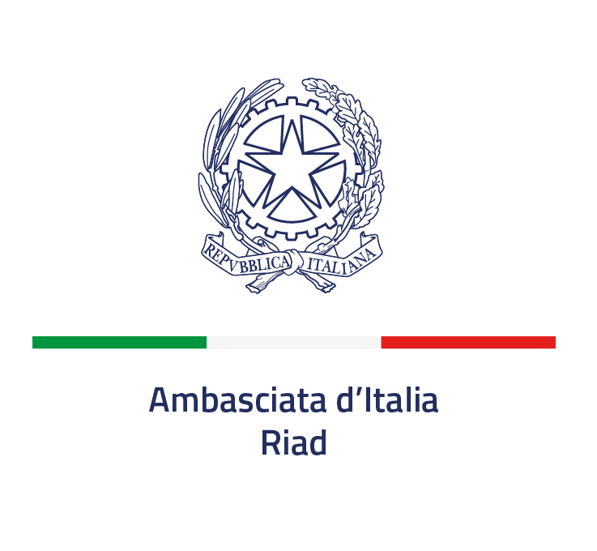

“Italian Bilateral Scientific Cooperation Award”

Purpose
The Italian Ministry of Foreign Affairs and International Cooperation (MAECI) established in 2017 the “Italian Bilateral Scientific Cooperation Award” to recognize the work of an Italian scientist who has remarkably contributed to the advancement of science and technology (S&T) while performing his/her research abroad, thus improving Italy’s S&T relations with foreign countries and International Organizations. All fields of science and technology are included under this award.
The Award is intended to strengthen scientific cooperation by funding the research stay, for a period of three months, at an Italian research institution, on the basis of a collaborative research project in the thematic area specified in the application.
The Award is funded by the Ministry of Foreign Affairs and International Cooperation (MAECI). The financial contribution shall be disbursed to the researcher through the host research institution.
The Award consists of a grant of approximately EUR 15,000, intended to cover all expenses incurred during the research residency at the designated Research Centre, including accommodation, meals, and any laboratory-related costs. Round-trip airfare and insurance costs are excluded from the grant and will be covered by Office XI of the Directorate General for Growth and Promotion of Export (DGCE) of the MAECI.
The host institution shall be designated by the Conference of Presidents of Italian Public Research Institutions (Consulta dei Presidenti degli Enti Pubblici di Ricerca – CoPer), taking into account the preference indicated by the awardee in the motivation letter submitted with the application.
Eligibility requirements
- The “Italian Bilateral Scientific Cooperation Award” is assigned to an Italian scientist presently active in the Kingdom of Saudi Arabia, for his/her outstanding contribution to the advancement of bilateral scientific cooperation in any field of science and technology.
- The nominees should be a resident of the country where they are nominated for the award at least since January 1st, 2021.
- The nomination should be submitted by an eminent scientist who is holding a leading position in a Scientific Academy, University, Research Institute or S&T Department of the Government of the country in which the nominee is working. Self-nominations are not eligible, nor are nominations from immediate family members. Teams are not eligible for the nomination. Qualified nominators may be:
➢ Heads of University or Scientific Institutions
➢ Members of Academies of Science
➢ Holders of Research Chairs
➢ Full professors

- The nominee should be an independent scientist with 3-7 years of experience since completion of their PhD degree, holding a very good scientific track record and carrying out top level research activities in collaboration with foreign scientists active in the Country where they live and work. Research activities within multilateral organizations are also eligible.
- Age limit: up to 35 years of age at the time of publication of this notice

Evaluation Criteria and Selection Procedures
Nominees will be evaluated on the basis of the following criteria:
- Scientific impact of the work presented;
- Relevance of the nominee’s work for Italian S&T cooperation with the Kingdom of Saudi Arabia;
- Nominee’s capacity to keep contacts with the Italian scientific community and corresponding potential for significant, long-term international collaboration;
- Promotion of young researchers’ mobility to and from Italy as a mean to foster the establishment of bilateral research teams;
- Nominee’s contribution to creative/innovative collaboration models;
The Award Committee, chaired by the Head of Office XI of the Directorate General for Growth and Export Promotion at MAECI, will be composed by representatives of the Conference of Presidents of Italian Public Research Institutions (Consulta dei Presidenti degli Enti Pubblici di Ricerca – CoPer);
Disbursement of the Financial Contribution
The arrangements for the disbursement of the financial grant shall be governed by a separate agreement between the MAECI and the host Research Institution. The award recipient is required to submit a Letter of commitment addressed to the host university or public research institution, indicating the period of the research stay, which shall not be less than three months.

How to Apply
The Call for Nominations will be published on the websites of the Italian Embassy in Riyadh.
Any scientist and scientific institution willing to present a nomination may submit the form herewith enclosed, duly completed, to the following email address: commerciale.riad@esteri.it

Nomination Form

Nominee
Name:
Institution:
Present Position:
Postal address:
Email address:

Nominator
Name:
Institution:
Present Position:
Postal address:
Email address:

Please send the form to the Italian Embassy in Riyadh by the 19.09.2026, together with the following attachments in .pdf file:
- Short motivation for awarding this prize and for the choice of the host research institution (maximum 100 words) signed by the “nominator”.
- Nominee’s major scientific achievements (maximum 1 page).
- Nominee’s short CV (maximum 2 pages) according to the applicable law in data protection.
- List of Nominee’s most important publications (maximum 1 page).
- Nominee’s activities with the Italian scientific community (maximum 1 page)
- Optional letters of support for the nomination (maximum 2 letters of maximum 1 page each) The letters of support shall be provided by eminent scientists other than the nominator.

All information provided will be treated according to the Italian Law (D.Lgs 196/2003 and Regolamento UE 2016/679)

Attached 1_TO BE SIGNED BY EACH APPLICANTS

Information on the protection of individuals with reference to the processing of personal data (General Data Protection Regulation (EU) 2016/679, art. 13)

The processing of personal data required for the purpose of participating in the “Italian Bilateral Cooperation Award” will conform to the principles of lawfulness, correctness and transparency in order to protect the fundamental rights and freedom of individuals.
To this purpose, the following information is provided:
1. The Data Controller is the Ministry of Foreign Affairs and International Cooperation (MAECI) of the Italian Republic which, in this specific case, operates via Office XI DGCE – (dgce11@esteri.it; tel. 0039 0636912737; commerciale.riad@esteri.it).
2. For inquiries or complaints, interested parties are entitiled to address the MAECI data protection officer / DPO [responsabile protezione dati / RPD] (mailing address: Ministero degli Affari Esteri e della Cooperazione internazionale, Piazzale della Farnesina 1, 00135 ROMA, telephone: 0039 06 36911 (switchboard), email: rpd@esteri.it, certified email [pec]: rpd@cert.esteri.it).
3. The personal data requested are needed to participate in the selection procedure for the present call. The processing of recipients’ personal data is meant exclusively for the purposes of the selection procedure for the award of the prize “Italian Bilateral Cooperation Award”.
4. The legal bases applicable are: the “Italian Bilateral Cooperation Award” selection procedure; the Italian legislation on administrative transparency; the applicant’s consent; the EU Data Protection Regulation (EU 2016/679). The applications will be dismissed in the following cases:
- No data are provided, or
- the applicant’s consent is withdrawn.

5. Data processing, performed by especially appointed personnel, will be carried out by manual and automated modalities exclusively for the purposes of the present selection procedure.
6. Personal data provided will be exclusively processed by persons responsible for the selection procedure, whose interest is legitimate according to Italian law, or to whom such data is owed by legal requirements. The recipient’s CV and name will be released to the press.
7. Personal data of the prize recipients shall be retained indefinitely for documentation. The remaining applicants’ personal data shall be retained for a maximum of 10 years after the award ceremony.
8. Applicants may request access to their personal data as well as their correction. Within the limits established by current legislation and without prejudice to any consequences on the outcome of the selection procedure, applicants may also request the cancellation of such data, as well as limitations of – or opposition to - data processing. In such cases, applicants must submit a specific request to the MAECI data protection officer (see art. 1).
9. If you believe your rights have been violated, a complaint may be addressed to the MAECI DPO (see art. 2.). Alternatively, you may contact the Italian Data Surpervisory Autorhitiy [Garante per la Protezione dei Dati personali] (mailing address: Piazza Venezia, 11 00187 ROMA, telephone: 0039 06 696771 (switchboard), email: protocollo@gpdp.it, certified email: protocollo@pec.gpdp.it)

Date and Place Signature

