Attachment 2

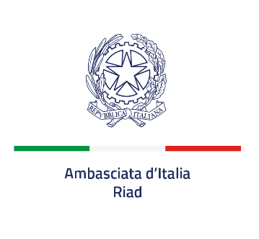

SINGLE REQUIREMENTS DOCUMENT

PART I:
INFORMATION ABOUT SPONSORSHIP PROCEDURE AND SPONSEE

Sponsee | Embassy of Italy in Riyadh
Title of the sponsorship: | Celebration of the Italian Republic Day scheduled on 21st of May and events in the framework of the Integrated Promotion Program 2026

PART II:
INFORMATION ABOUT THE SPONSOR

A. Sponsor identification data

Name:

National identification number, if applicable (tax code, VAT number, registration)

B. Representatives of the sponsor:
Full name:

Date and place of birth:

Position / Title:

Postal Address:

Telephone:

E-mail:

PART III:
EXCLUSION CRITERIA

A: Reasons related to criminal convictions
Those who have been convicted, with a definitive criminal sentence, in Italy, elsewhere or in the country where the sponsorship takes place, are excluded from participation in the selection.

B: Reasons related to the payment of taxes or social security contributions
The Sponsor has fulfilled all obligations relating to the payment of taxes, fees or social security contributions, in the country where it is established, in Italy, and in the country where the sponsorship takes place.

C: Reasons related to insolvency, conflict of interest or professional misconduct

D: Reasons for exclusion provided by the Italian law and equivalent situations provided by the law of the Country where the sponsorship takes place

PART IV:
SELECTION CRITERIA

The Sponsor meets all the selection requirements reported by the notice published on the website of the Embassy of Italy in Riyadh on 01 February 2026 concerning the search of sponsors for the celebration of the Italian Republic Day, scheduled on 21 May 2026, and the events in the framework of the Integrated Promotion Program 2026 of the Embassy of Italy in the Kingdom of Saudi Arabia.

PART V:
FINAL STATEMENTS

The undersigned hereby certifies the absence of the exclusion criteria reported under Part III and the fulfillment of the selection requirements referred to in Part IV.

The undersigned formally declares that the information contained in parts II to IV is true and correct and that the undersigned is aware of the consequences, including of a criminal nature, of a serious false declaration, provided for by Italian law and by local law.

Place and date
_______________________________________
[name, surname and position of the signatory]

