Attachment 3
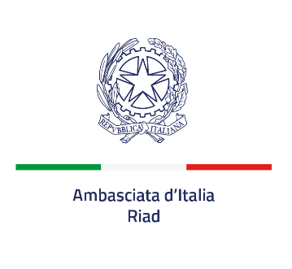
Information on the protection of individuals with reference to the processing of personal data
(General Data Protection Regulation (EU) 2016/17, art. 13)
The processing of personal data required will conform to the principles of lawfulness, correctness and transparency in order to protect the fundamental rights and freedoms of individuals.
To this end, the following information is provided:
- The Joint Controller is the Ministry of Foreign Affairs and International Cooperation (MAECI) of the Italian Republic which, in this case, operates via the Italian Embassy in Riad., located in As Safarat - 3639 Amr Aldamri St. Riyadh 12512 – 7961 Kingdom of Saudi Arabia - P.O. Box 94389 - Riyadh 11693, e-mail: commerciale.riad@esteri.it and segr.econ.riad@esteri.it
- For inquiries or complaints, interested parties may contact the Ministry of Foreign Affairs and International Cooperation Head of Personal Data Protection (RPD) (mailing address: Ministry of Foreign Affairs and International Cooperation, Piazzale della Farnesina 1, 00135 Rome, telephone 0039 06 36911 (switchboard), email: rpd@esteri.it, certified email [pec]: rpd@cert.esteri.it).
- Personal data is necessary for the selection of the economic operator chosen for the tender.
4. Provision of this data is an Italian legal requirement, and any refusal to provide the requested data will lead to exclusion from the selection process.
- Data processing will be carried out in both manual and automated modes by specially appointed personnel.
- Data will be communicated to the internal and external control bodies of the Ministry of Foreign Affairs and International Cooperation. By signing this notice, the interested party acquiesces to the conveying of said data also to competent local authorities for their inspection, and to the publication of essential parts of the agreed contract on the contracting authority website, in accordance with Italian regulations on transparency of public contracts.
Data shall be retained for a maximum period of five years starting from when the contractual relation ends, because its execution is complete or for other reasons, including termination for non-performance. This deadline is suspended in the event of the start of legal proceedings.
- Interested parties may request access to their personal data and the correction of the same. In these cases, interested parties must submit a specific request to the addresses set out in point 1, and notify the MAECI Head of Personal Data Protection (address in point 2) of the same.
- If you believe your rights have been violated, you may file a complaint with the MAECI RPD. Alternatively, you may contact the Garante per la Protezione dei Dati personali [Data Protection Authority] (Piazza di Monte Citorio 121, 00186 ROMA, telephone 0039 06 696771 (switchboard), email: garante@gpdp.it, certified email: protocollo@pec.gpdp.it) or to judicial authorities.
Place and date
Signature of the Company’s Legal Representative, acknowledging and accepting

-----------------------------------------

